Create Awesome **title page** with the following content

* Report Title
* Team Members
* Date of the Report
* Name of Sponsoring Company
* Academic/Industry Advisors
* Include the sentence
  + “ME 493 Final Report: Spring 2019”

Outline

1. Executive Summary
2. Table of Contents
3. Introduction and Background Material
4. Mission Statement
5. Main Design Requirements
6. Brief Discussion of the top-level alternative conceptual solutions, the chosen design, and justifications to strengths of the chosen design
7. The final design (easy to understand format)
8. Present the results of various evaluations as required by PDS
9. Conclusions and Recommendations
10. All supporting materials [Appendices]

Begin working creating and edit sections below this page.

**Executive Summary**

Portland State Aerospace Society (PSAS) requires a Flight-Ready Electric Feed System for their upcoming Launch Vehicle 4 (LV4). An Electric Feed System (EFS) is an electronically controlled pump system used to provide the necessary pressure to deliver liquid propellant to the engine. The EFS must be cryogenic compatible to withstand the environment that the liquid oxygen (LOX) and isopropyl alcohol (IPA) propellants create. While this project has yet to provide a flight-ready system, significant headway was made on developing a cryogenic compatible system. Improvements were made upon the previous design, and recommendations on how to proceed are being drafted for future EFS design teams.

**Blue means pull from winter document, green means done**

**Table of Contents**

1. Introduction
2. Mission Statement
3. PDS
4. Concept Designs
   1. Single Engine - Twin Pumps
      1. Axial Inline Pump
      2. Axial Split Single Suction
      3. Barrel Pump with Bevel Gears
   2. Twin Engine - Twin Pumps
5. Final Design Selection
   1. Material Properties
   2. Impeller Design
   3. Machinability
   4. Power Components
   5. Internal Components (seals-bearings)
   6. Test Assembly
6. Pump Result Breakdown
   1. IPA Pump Performance
      1. Test One
      2. Test Two
      3. Test Three
   2. Cryo Pump Performance
      1. Test One
7. EFS Onboarding
   1. Pump System Mechanics
   2. Design Goals
   3. Recommendations
   4. Continuing Design
      1. LV4 Integration
         1. Test Stand
         2. LV4 Airframe
      2. Pump Internals
         1. Bearings
         2. Seals
         3. Alignment
      3. Testing Procedures
8. Conclusion
9. Appendices

**1. Introduction**

The final system deliverable is expected to meet the following chemical compatibility, operating temperature conditions, performance efficiency, vibrational disturbances, and control signal data. PSAS also expects complete documentation of background research procedures for pump mounting and operations. Final deliverables must be within budget and completed by June 2019.

**2. Mission Statement**

The Electric Feed System Capstone aims to provide affordable, lightweight propulsion system technology to increase the capabilities of amateur rocketry and student education.

**3. Product Design Specifications (PDS)**

PSAS provided baseline requirements for the project to outline the expectations and reach goals for this Capstone. Tables 1 outlines and ranks the customer needs from highest to lowest priority items, with 5 being top priority, as of May 2019. The Customer needs to outline the necessary design requirements metrics are shown in table 2, and the derived engineering requirements are shown in table 3.

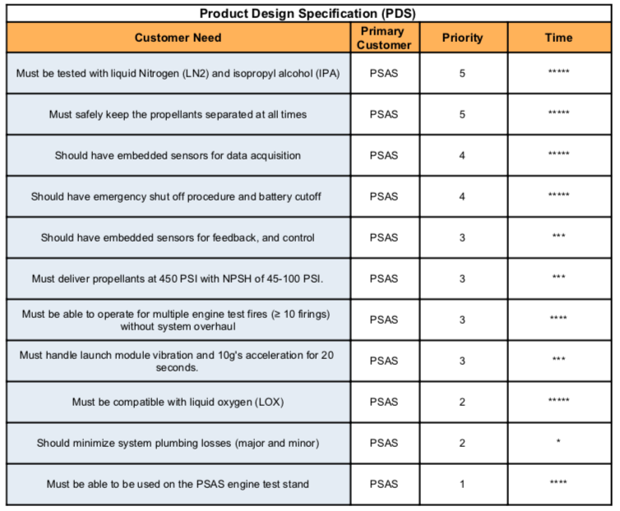

*Table 1: PSAS customer needs for the Electric Feed System Capstone Team ranked by priority*

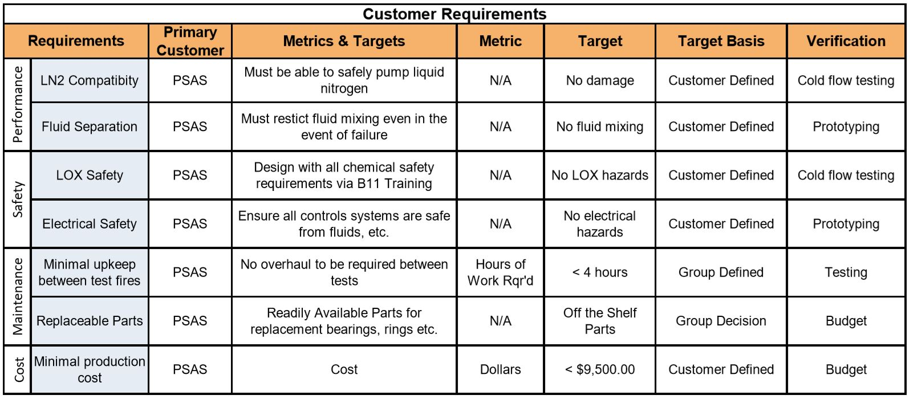

*Table 2: EFS Customer Design Metrics*

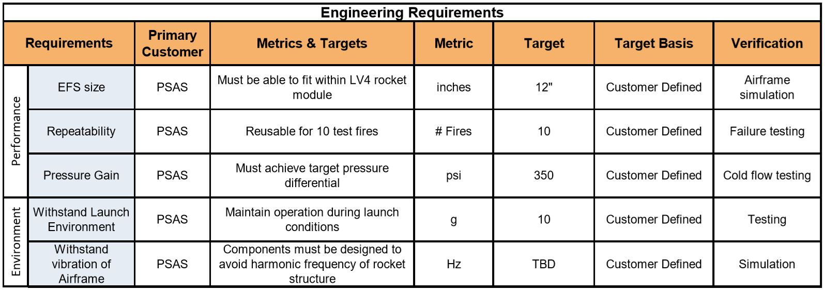

*Table 3: EFS Engineering Design Metrics*

**4. Concept Design**

The following sections provide the background to previous design ideas for the electric feed system pumps leading to the final manufactured design.

**4.1 Single Drive Dual Pump Design**

Initially, the EFS was conceptualized as a pumping system in which two centrifugal pumps were driven by a single power source. The goal of this design was to decrease the total space and weight used by the electric feed system by reducing the need for a second motor.

**4.1.1 Axially Split Inline Pump**

The first design concept for the EFS featured two pumps with axially split pump cases running inline with the same drive shaft. The center pump would have a pass-through shaft with bearing housings on either side of the pump to allow the shaft to continue out to drive the second pump, as shown in Figure ##.

While the use of a single drive in this context would reduce the weight of the system by the removal of one motor, it was concluded that this design was not feasible after preliminary hydraulic calculations were made. Each fluid requires a different rotational speed to achieve the appropriate pump specific speed required for suction[1], so it was concluded that the two pumps could not share a drive directly.

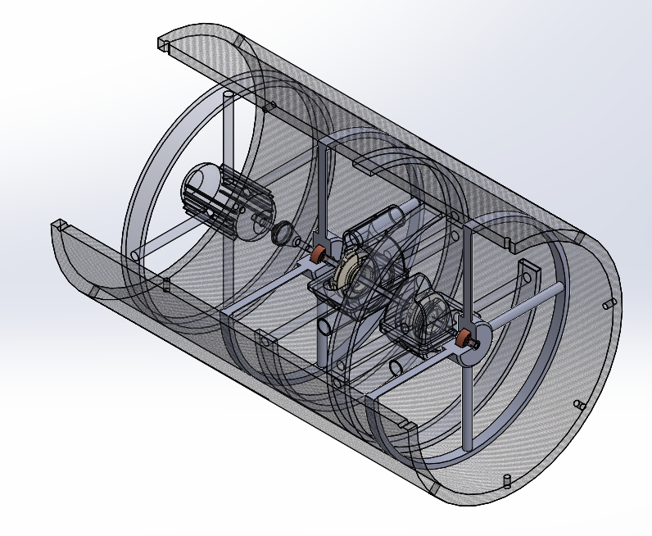

**4.1.2 Barrel Pump with Bevel Gearbox Drive**

Given the issues with running a single drive inline, a design was generated that featured a single motor used to drive a bevel gearbox. Both pumps were then run orthogonally from the direction of the motor shaft, as shown in Figure ##.

This design would allow for separate rotational speeds by utilizing gear ratio relationships to drive the two pumps at different rates. However, this would require a motor with very high power density, which was determined to be outside of the scope of the project budget. Additionally, the use of a gearbox would result in larger amounts of energy loss and overall system inefficiency, which would not be optimal for integration into the rocket. Moreover, the energy lost to the gearbox would result in a large amount of heat generation in close proximity to the flow region of the cryogenic fluid, resulting in two-phase flow and risk of cavitation in the LOX pump.

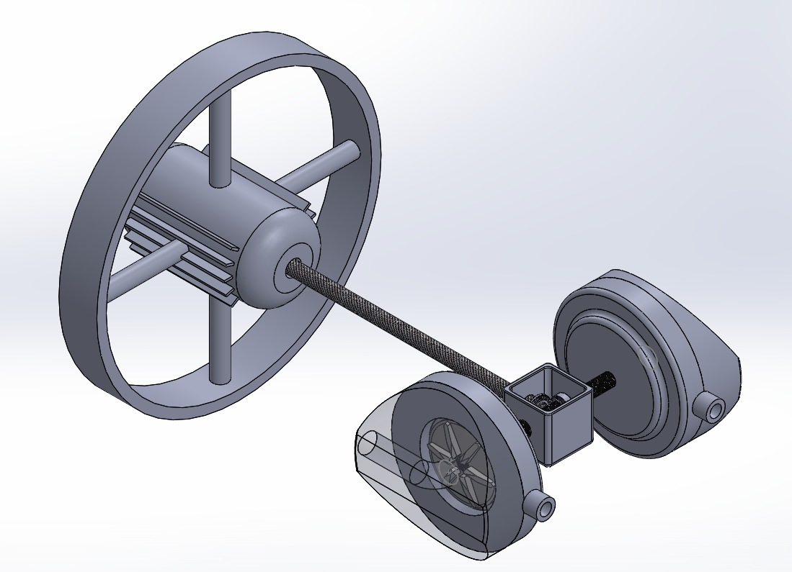

**4.2 Dual Drive Parallel Pump Design**

The optimal pump orientation was decided to be two pumps running parallel to each other on separate drive shafts. While the second motor and mount add additional weight, the system is more reliable and more effective overall, as two motors with the required separate power densities can be procured for less than the cost of a larger single shaft drive system with comparable power density. Additionally, this design allowed for the fabrication and testing of initial prototypes for IPA while design and analysis continued to be performed for the LOX system.

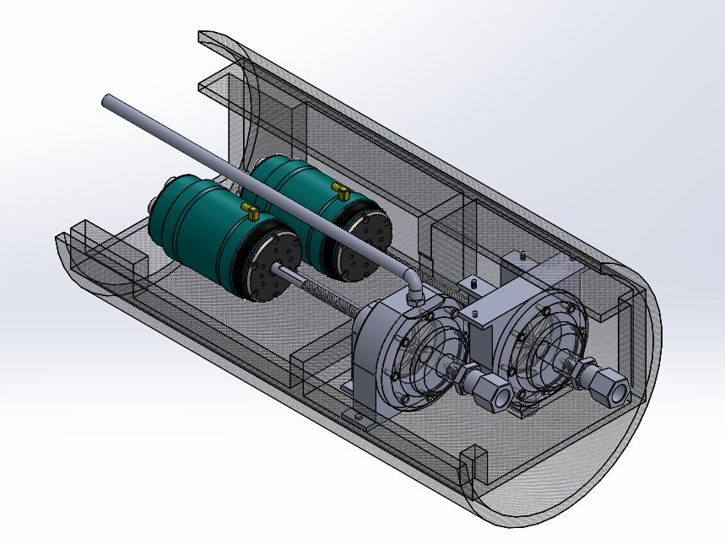

**5. Final Design Selection**

The dual drive option was selected as the optimal power system configuration, as it allows for the greatest level of independence for rotation speeds between the two fluid pumps while remaining reliable and cost-effective. The final design consists of a three-piece pump housing that is assembled piecewise along the shaft axis, as shown in Figure ##. The two assembled housings are mounted into the corners of the module mount, fastened in an orthogonal pattern to handle shock and vibration symmetrically in the XY plane. The final design’s motor is mounted to the pump housing itself rather than the module mount, as this ensures optimal alignment from the drive shaft to the impeller, as shown in Figure ##. flow is plumbed downward into the impeller eye opposite to the rocket’s acceleration direction in order to achieve the flow rate calculated based on the rocket’s ideal thrust. The outlet plumbing exits the side of the pump and is fed down to the engine.

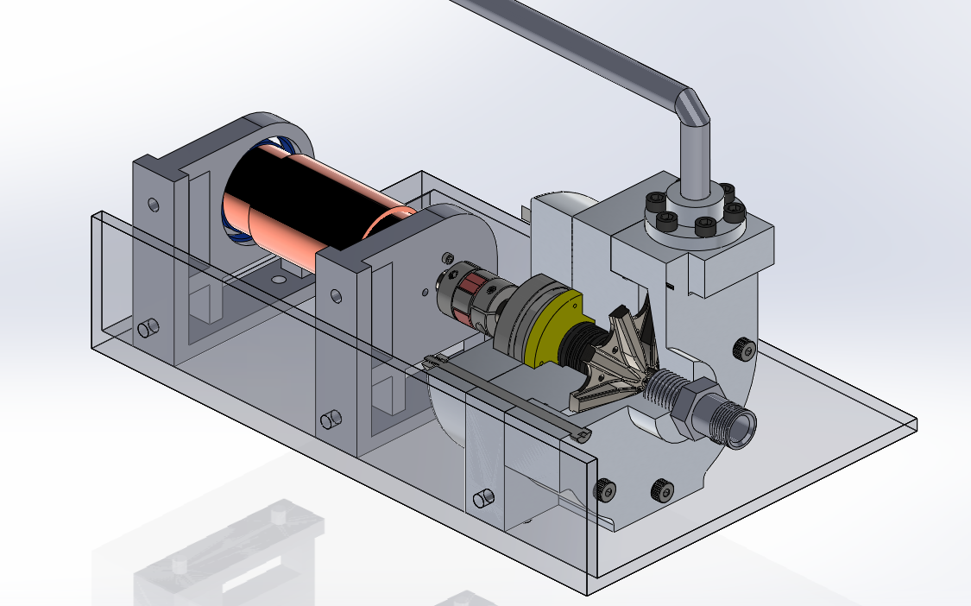

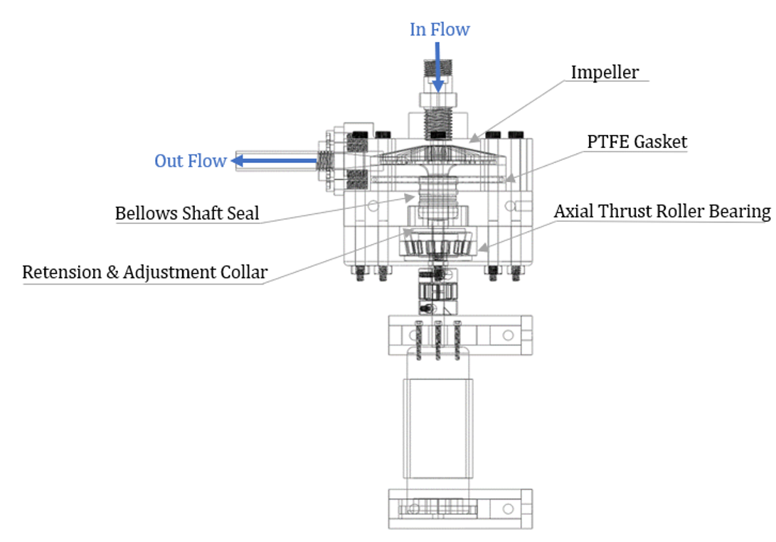

**5.1 Material Properties**

Research in material properties and compatibility led to the selection of Aluminum 6061 for the fabrication of both the isopropyl alcohol and liquid oxygen pumping systems. The primary factor impacting this decision was material compatibility with LOX. Because of the volatile properties of liquid oxygen, material selection for this fluid required the consideration of a number of safety and reliability factors, including oxidation, corrosion, and cavitation. It was decided that an aluminum alloy would be the safest selection based on the research performed in these areas.

6061 was selected as the ideal alloy for this project’s application, as it is relatively low-cost and is more machinable than stainless steels, which were also considered for use. This allowed for more practical in-house fabrication, lowering the cost of production and lead times.

The material behavior of this alloy was also determined to be the most desirable for cryogenic applications. While most stainless steels may have higher strengths and lower tendencies to oxidize, it was found that aluminum 6061 is more ductile at cryogenic temperatures than any of the stainless steels researched. At the pressure magnitudes required for the electric feed system to operate, loss of ductility generated risk of ductile-to-brittle transition for the stainless steels considered.

Table ##: Material Selection Matrix

|  |  |  |  |  |  |  |
| --- | --- | --- | --- | --- | --- | --- |
| Material | Mechanical Properties | Machinability | Cost | Extreme Temperature Performance | LOX Compatibility | Score |
| Aluminum 6061 | 3 | 5 | 5 | 3 | 2 | 18 |
| Aluminum 7075 | 3 | 5 | 2 | 3 | 3 | 16 |
| SS 304 | 5 | 1 | 2 | 1 | 5 | 14 |
| SS 316 | 5 | 1 | 2 | 1 | 5 | 14 |

**5.2 Impeller Design**

In EFS pumps, a specialized impeller is required to provide high-pressure gains while maintaining a low flow rate. Taking into consideration the previous team’s research as well as industry literature on liquid propellant rockets, we found a Barkse impeller design to be the most favorable for this application. These impellers are intentionally designed to be inefficient. This inefficiency allows for large pressure gains while maintaining low flow rates. The previous team also tested a variety of impeller designs with a varying number of vanes. It was found that 10 vanes were the most efficient number of vanes for the pump.

Another critical design decision involved in the impeller was the impeller and shaft connection interface. The impeller needed to be able to withstand high torque values and be machinable within the campus machine shop. The final design evaluation for the impeller resulted in the selection of a single-piece shaft. It was determined that this design could be made in-house at PSU from 3” diameter, 3 ¾ long raw stock 6061-T6 aluminum. This design scored the highest against the matrix design criteria and was selected to move forward with to begin prototyping.

**5.3 Manufacturing**

* Machines available
* Tooling available
* Flexibility with functional prototypes
* Decision to manufacture in house. Reduced costs

**5.4 Power Components**

The requirements for shaft power led us to select a TP Power 4070CM as the BLDC motor for the IPA pump along with a Swordfish 200A electronic speed controller (ESC). Including the batteries and other accessories, this combination was within budget, at around $1000, and well exceeded the requirements for the IPA system. Purchasing an overpowered motor for the IPA pump increased our design efficiency by replicating the components to the cryogenic pump after testing and fine tuning is completed. The use of identical motor systems for both pumps saved time and freed up to focus for other components.

Safe operation is a strong requirement for the system to be considered successful. This project is to focus on designing for the flight which entails autonomous operation for the EFS. When selecting the ESC, batteries, and connectors, safe autonomous operation during the flight was prioritized by PSAS for the team. Gold plated, 8mm bullet connectors are found along with the entire wire harness because they offer a safety factor of 1.75 against high current load damage. This minimizes the risk of meltdown and electrical fires. The batteries powering the motor have a 350A capable discharge rate which provides a 1.88 safety factor, once again, against fires due to meltdown or damage from high current demand from the motor. Lastly, the Swordfish 200A ESC provides a built-in water cooled case for heat dissipation and a safety factor of 1.34 against damage due to high current.

**5.5 Internal Components**

Phil

**5.6 Test Assembly**

To facilitate quick testing, a mobile test stand was used to

**6. Pump Results Breakdown**

**6.1 IPA Pump**

**6.1.1 Test One**

Test one of the full IPA pump assembly was performed after all machined components were completed. Initial setup of the system proved difficult as we discovered there was not an accurate method for positioning the components along the shaft. Our design called for clearances as small as 0.008 inches between parts and there was no way of measuring the internal component positioning. The greatest risk associated with the unknown positioning was the impeller contacting the inside of the pump housing. To monitor this possibility, the inside of the pump housing was painted so disturbances could be observed after testing was completed.

To begin testing, we slowly turned the potentiometer on so that the motor would start at a lower speed. Immediately upon startup, rubbing and churning noises came from the system. With no obvious sign of what was making the noise, we cut the test immediately. After inspection of all external components and still no sign of interference, we tried them again. The same noises ensued, however, this time we decided to keep the system running a few moments longer to see if things would pick up and engage. During the second attempt, a loud *pop* came from the ESC and the system came to a halt. The ESC had. We suspected this was either from an overload in current or water entering the ESC housing.

The system was disassembled and inspected for the further prognosis of the unknown noise. Scratches were found in the paint on the inside of the pump housing which verified contact of the impeller. We did not believe this was the cause of the noise. Discussion among group members revealed the difficulty that existed in turning the impeller by hand. Questions arose around whether there were inaccuracies within the concentricity and alignment of the components. The noises were thought to have come from two or more internal components rubbing on each other. Other possibilities left open for investigation were the possibility of bearing wobble, sticking seals, and too much tension in the seals.

Further time would need to be invested into the cause of the short-circuited ESC and failed test. A replacement ESC was ordered and all internal components were evaluated after testing.

**6.1.2 Test Two**

After the first test, we were able to diagnose some of the issues and made some modifications to the pump case. In order to release the tension that been put on the seal, the lower pump case was been re-machined. This time we increased the inside diameter of the lower casing. By doing that, we let the dynamic seal made contact directly with the lower face of the impeller. The result showed us that the tension on the seal was released. The reason we did that is to decrease the pressure that been put on the impeller and to make it spin freely with no contact with either of the faces. After the new ESC had arrived, we came up with the countermeasure for it. We used the hot glue and sealed the open areas in order to isolate the circuit board from the outside atmosphere to prevent the water been leaked in.

The second test was implemented after all of the problems have been fixed. The test procedure was strictly followed by the first test. After the power been turned on, there was no problem in the control circuit, as we turn up the speed of the motor, the noise started to get loud, after a few seconds, there was a electric spark appeared around the ESC. We immediately aborted the test, because we were afraid that the new ESC would be destroyed. The similar problem has appeared at the second test. We disassembled the entire system and tried to find the problem.

After the pump takes down from the test stand, we were found that the motor was still hard to turn with the impeller shaft. After the pump casing was separated, we found that there was a scratch on the inside of the upper casing, the cause of that was due to the impeller been contacted with the face of the case. When we separated the bearing case with the lower case, there was water leaked into the gap between those two faces. We were assuming that making the seal in contact with the impeller has made the seal lost efficacy. As the seal not only lost the function as a dynamic seal but obstructed impeller moving freely. Because there was such a big force was put on the motor, it was also increased the resistance on the circuit board which caused the power surge that fried the component of the circuit.

We were trying to see if the ESC was able to work again without everything being put on the motor. The result showed that the component that communicates with the motor was damaged, so the ESC was not working properly, and a replacement has to be ordered. As we examed every component been put on without the upper case, we also found that there was an alignment issue. As we tied up the coupler, the impeller shaft and motor shaft were not aligned, which would also cause the one side of the impeller been touched with the upper case. Based on all of the problems, the proper measures were been used to the new cryogenic pump design.

**6.1.3 Test Three**

**6.2 Cryo Pump**

**7. EFS Onboarding**

**7.1 Design Goals**

**7.2 Recommendations**

**7.3 Continuing Design**

**7.3.1 LV4 Integration**

7.3.1.1 Test Stand

7.3.1.2 LV4 Airframe

**7.3.2 Pump Internals**

7.3.2.1 Bearings

7.3.2.2 Seals

7.3.2.3 Alignment

**7.3.3 Testing Procedures**

**8. Conclusion**

**9. Appendix**

* Insert Finished Gantt Chart